Object pool pattern is a software creational design pattern which is used in situations where the cost of initializing a class instance is very high.

Basically, an Object pool is a container which contains some amount of objects. **So, when an object is taken from the pool, it is not available in the pool until it is put back.**

Objects in the pool have a lifecycle:

Creation

Validation

Destroy.

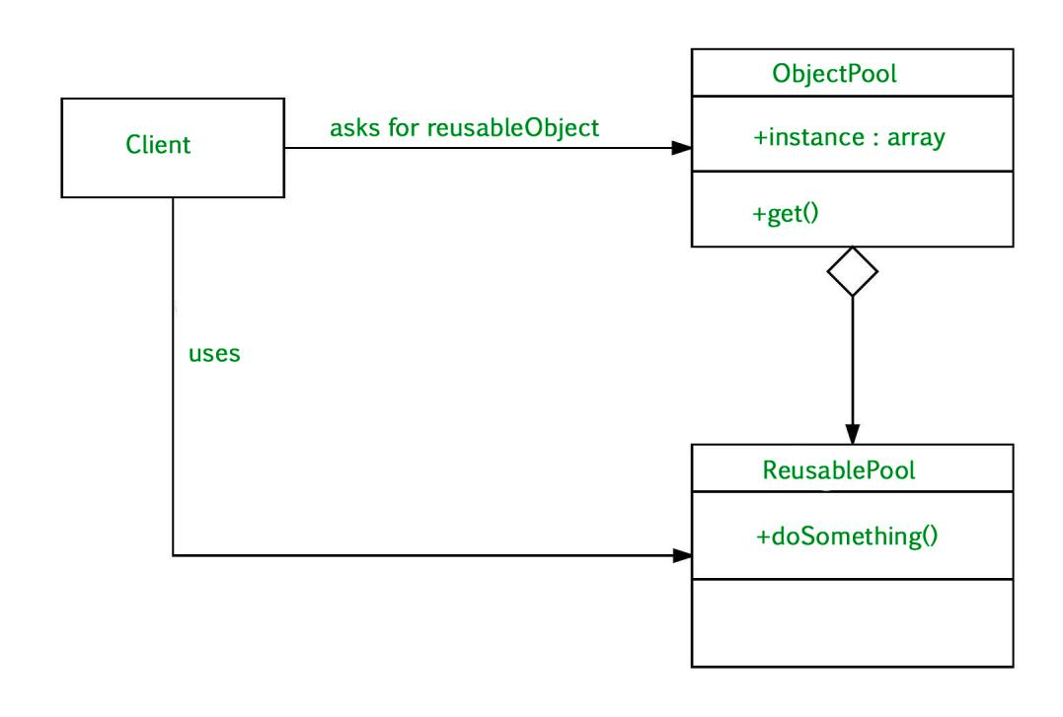

**Client :** This is the class that uses an object of the PooledObject type.

**ReuseablePool:** The PooledObject class is the type that is expensive or slow to instantiate, or that has limited availability, so is to be held in the object pool.

**ObjectPool :** The Pool class is the most important class in the object pool design pattern. ObjectPool maintains a list of available objects and a collection of objects that have already been requested from the pool.

**An Example Where Object Pool Can Be Used:**

Let’s take the example of the database connections. It’s obviously that opening too many connections might affect the performance for several reasons:

Creating a connection is an expensive operation.

When there are too many connections opened it takes longer to create a new one and the database server will become overloaded.

Here the object pool manages the connections and provide a way to reuse and share them. It can also limit the maximum number of objects that can be created.

**Advantages**

It offer a significant performance boost.

It manages the connections and provides a way to reuse and share them.

Object pool pattern is used when the rate of initializing a instance of the class is high.

When to use Object Pool Design Pattern

**Disadvantages:**

When we have a work to allocates or deallocates many objects

Also, when we know that we have a limited number of objects that will be in memory at the same time.